CALL FOR SUBMISSIONS:
Community engagement for inclusive rural transformation and gender equality
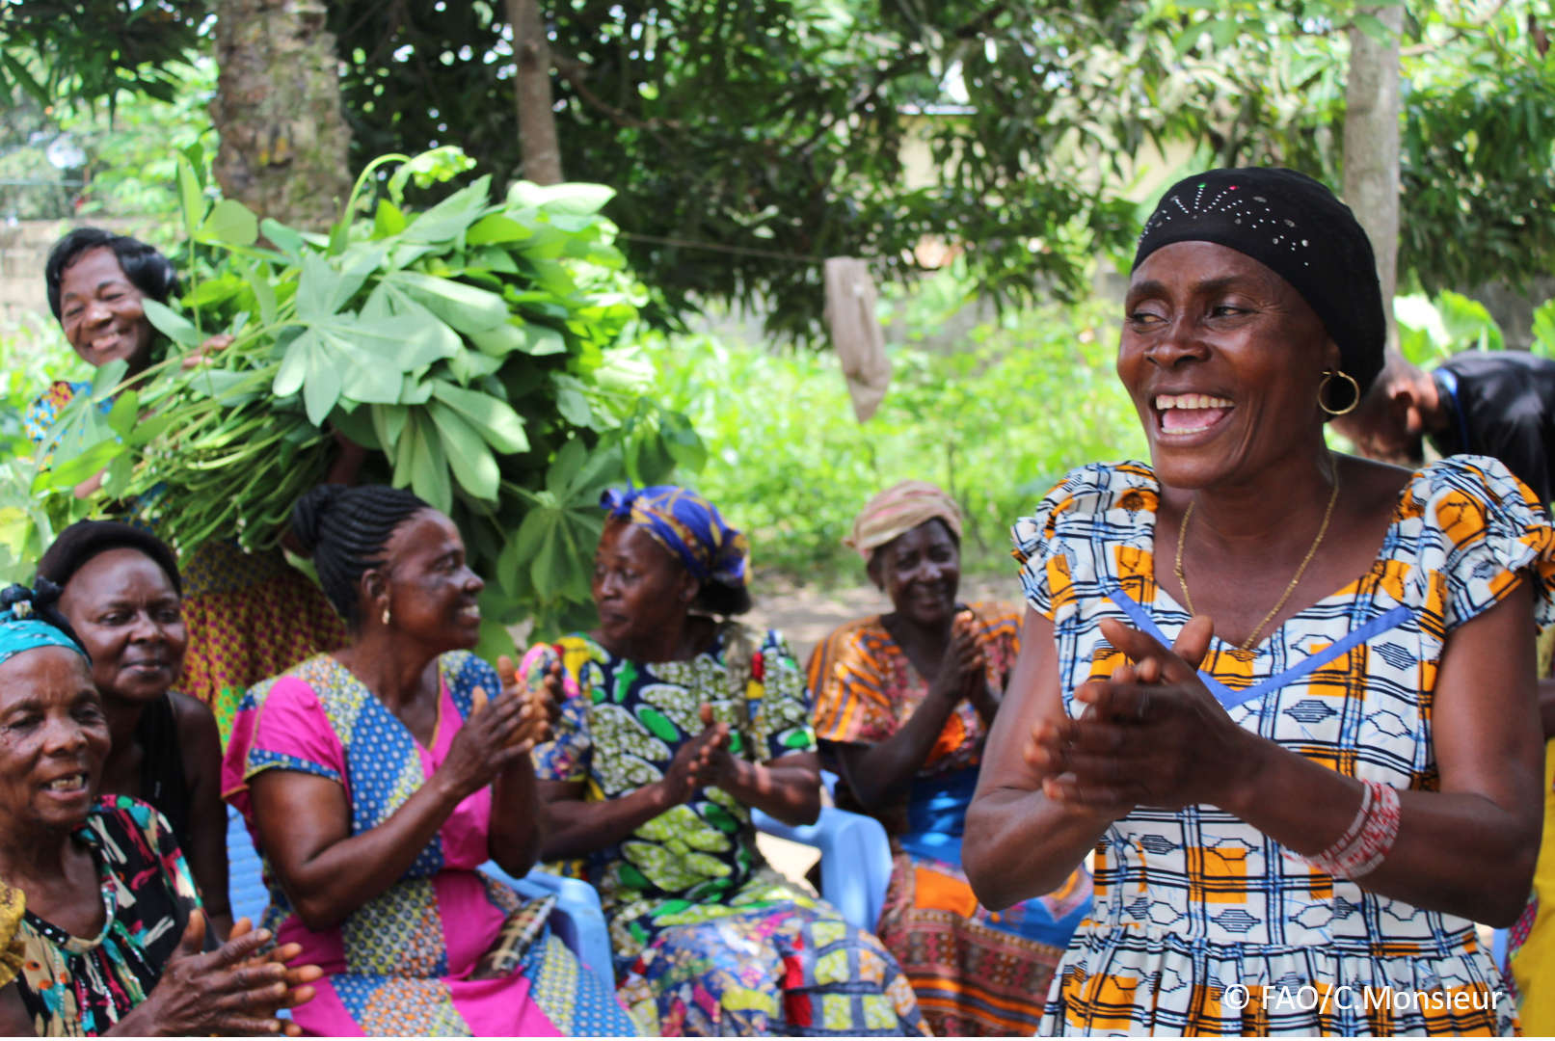
The objective of this call for submissions is to collect good practices, experiences, and lessons learnt on the use of community engagement for inclusive rural transformation and gender equality. The initiative, organized by the Rural Transformation and Gender Equality Division (ESP), seeks to gather insights from a diverse range of contributors, both within FAO and from external stakeholders. Its goal is to share knowledge, foster learning, and guide the scaling up of community engagement and community-led collective action to leave no one behind. The call builds on FAO's past efforts in this area, such as the Community Engagement Days series of webinars.
The call for submissions is open until 27 November 2024.

How to take part in this call for submissions:
To take part in this Call for submissions, please register to the FSN Forum, if you are not yet a member, or “sign in” to your account. Please review the topic note to understand the criteria we are considering for this call. If you wish to learn more about community engagement, you may refer to the background document. Once you have completed this submission template, upload it in the box “Post your contribution” on the call webpage, or, alternatively, send it to fsn-moderator@fao.org.
Please keep the length of submissions limited to 1,500 words and feel also free to attach relevant supporting materials.

Template for submissions

Contact person | Name: Esther Ronner  Organization/Unit: Wageningen University & Research  Country: The Netherlands  Email address: esther.ronner@wur.nl
Name/title of the good practice | The Participatory Integrated Planning approach  (PIP approach)
Where is the good practice taking place? (Multiple selection allowed) | ☐ Europe and Central Asia  ☐ Latin America and the Caribbean  ☐ North Africa and Near East  ☒ Sub-Saharan Africa  ☐ Asia and the Pacific  ☐ North America  ☐ Global
Affiliation | ☐ Farmer and producer organizations  ☐ Trade Union  ☐ Informal community-based, farmer-based or self-help group  ☒ Research and academia  ☐ Government  ☐ Local/traditional authorities  ☐ Private Sector  ☐ Civil Society Organization  ☐ Intergovernmental Organization (e.g. UN system, World Bank)  ☐ Resource Partner/Donor  ☐ Other (please specify)
In which sector(s) and context (s) have you used this community engagement good practice? (Multiple selections allowed) | ☐ Education  ☐ Health and Sanitation  ☒ Food production in agrifood systems (please also tick the sub-categories)  ☒ Crop cultivation  ☒ Fisheries and aquaculture production  ☒ Livestock  ☐ Forestry  ☒ Agroforestry  ☐ Horticulture  ☐ Apiculture (beekeeping)  ☒ Agroecology and sustainable farming practices  ☒ Soil and water management  ☐ Other: ____________  ☐ Post-production in agrifood systems (please also tick the sub-categories)  ☐ Processing and value addition  ☐ Marketing and retailing  ☐ Transporting  ☐ Food loss and waste  ☐ Packaging  ☐ Storage  ☐ Distribution  ☐ Other _________  ☒ Gender Equality  ☐ Climate Action  ☒ Citizenship and Governance  ☒ Social Protection  ☐ Humanitarian and protracted crisis  ☒ Conflict resolution, peace and resilience  ☐ Digital innovation  ☐ Other sector (please specify) _________
Who are the financial partners supporting this good practice, if applicable? | Not applicable
- In a few sentences, summarize your community engagement good practice.
The Participatory Integrated Planning (PIP) approach is an inclusive bottom-up approach that engages people in environmental stewardship and sustainable change. In East Africa, it has motivated tens of thousands of farmers to tackle land degradation and invest in their land. After households develop their own Participatory Integrated Plan, these farmer families become actors of change, determined to make their vision become reality: a more resilient farm and household as the foundation for a more sustainable future.
- What problem(s) or challenge(s) does your good practice aim to address through community engagement?
Land degradation is a major challenge for farming communities in many Africa countries. Particularly in the highlands of East Africa, farmer livelihoods depend on agricultural production on steep slopes. In combination with a rapidly growing population, mounting pressure on the land combined with unsustainable agricultural practices is leading to wide-scale deforestation, overexploitation of land and soil erosion. Past interventions often failed to persist because they focused on rapid implementation of e.g. tree planting, crop trainings, physical practices or ‘hardware’, rather than on long term outcomes and changes in behaviour. Or, food or cash-for-work approaches were used, incentivising people to change their immediate behaviour, (e.g. because they are paid to dig trenches in their field), but not creating long-lasting behavioural change. Breaking the “dependency syndrome” is one of the biggest hurdles to take, yet acting based on ownership and long-term goals is essential for sustainable development.
The PIP approach therefore focuses on empowering communities from the bottom-up, starting at household level to create a solid foundation for sustainable change. The PIP approach facilitates the creation of household, community and watershed visions and action plans, meanwhile emphasizing the urgency to act responsibly and collectively to tackle soil erosion, land degradation and declining productivity. The enhanced awareness of the present and potential future situation of the farm visualized in a drawing is the start of an empowerment process, where people and communities realize common goals and become agents of change. Awareness around household dynamics is created based on GALS, a gender-transformative approach, which improves communication between HH members, reduces conflicts and violence, and often leads to new dynamics of collaboration and motivated action. At community-level, PIP serves as entry point for collective actions on sustainable land use, collective marketing, collaboration in farmer groups and engagement with government authorities.
- Describe your good practice in more detail. Include the main guiding principles, the desired changes or outcomes you aim to achieve (Theory of Change), and the key phases of implementation.
The PIP approach is visualized in Figure 1. Just like a tree that needs fertile soil to grow strong, the PIP approach builds a foundation for sustainable change based on three principles: motivation, stewardship, and resilience. In the PIP approach, it is assumed that such a foundation of resilient and motivated stewards of the land and its natural resources, is essential for the sustainability of any intervention or action. This is illustrated in Figure 1 by the arrow pointing to activities such as livestock improvement, reforestation, value chain development, water projects, and microcredit schemes. All such activities are prone to face limited ownership and sustainability when the three principles of this foundation are not addressed. Furthermore, the blue outer circle of Figure 1 presents the three guiding principles of the PIP approach: empowerment, integration, and collaboration.
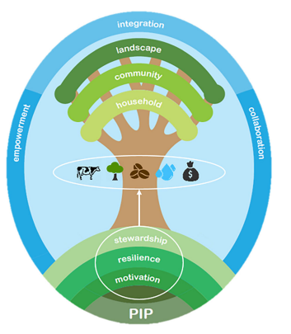
Figure 1: Visualization of the PIP approach. Source: Kessler et al., 2020.
These guiding principles encourage the implementing staff to always empower others, foster integration, and collaborate in their daily work. The scaling of the approach is illustrated by the branches of the tree, with the process starting at household level, spreading to community level and eventually covering an entire landscape.
Creating a farm or household PIP with each family is a key tool in the approach. This PIP creation, in which family members draw a vision and develop an action plan together, is a flywheel for all other changes that follow. By creating a PIP together, awareness grows within families about the importance of integrated planning and resolving social and intra-household issues. These dialogues on possibilities to improve together, reach attainable goals, and how to define this in a PIP, lead to better organized households with common objectives. What follows is motivated action, because a PIP is based on households' own capabilities and knowledge, and not on project targets or objectives. Similarly, at the community-level, village visions are developed as concrete plans for collective action, enhanced market access, landscape restoration, and well-organized village structures. Local institutions and extension workers are closely involved in all activities, given that their motivation and engagement are considered essential for local ownership and the sustainability of all actions.
A key starter activity is the development of household PIPs with a group of 25 PIP Innovators (PIs). After going through their training, PIs each train another ~10 farmers, who in turn are encouraged to train other farmers. Farmer-to-farmer transfer of knowledge and inspiration is therefore key in the approach. Eventually, this leads to an 80% coverage of households in a village, after which the process continues in neighbouring villages based on the same principle. In parallel, each village develops a village vision.

- Who are the key actors and stakeholders involved in the design and implementation of the good practice, and what are their respective roles? Consider local partners, government, local authorities, community radios, civil society, research, the private sector, etc.
The PIP trainings are given to local communities by field staff from local NGOs or community-based organisations. This staff is key to tailor the approach to the local context. In the development of village visions (or visions at higher institutional levels, including districts, watersheds, etc.), local government staff, extension agents, nature conservation organisations, etc. are part of the visioning process. Engagement with government and private sector is actively sought for the implementation of village visions, to collaborate in community development initiatives or to foster better market linkages.
- How does your intervention ensure inclusivity and equal and meaningful participation within the community?
Describe how your intervention includes and engages different groups within the community. Consider aspects like gender, age, ethnicity, disability status, livelihoods, and other specific conditions (e.g., people living in prolonged crisis, migrants, refugees). Explain how your intervention engages diverse segments of the rural community. Highlight the specific actions or strategies you use to reach these groups. If applicable, mention if your intervention uses specific approaches such as gender-responsive, gender-transformative, intersectionality, or other methods to ensure inclusivity and gender equality.
PIP, by default, is aimed at reaching entire communities, not sub-groups within a community. In the selection of PIs, and the committee responsible for development of the village vision, explicit attention is paid to the representation of different segments existing in the community, such as men/women/youth; farmers with large/small/no landholdings; with/without political influence; religious/tribal/immigrant groups, etc. This diverse representation is then continued in the training of the next round of households.
Social resilience is a key aspect of the approach, and the ‘gender balance tree’ from the GALS methodology is used to ensure that all household members are engaged from the onset of the planning. The approach is thereby inclusive for all household members throughout its activities.
- By using community engagement, what results and impacts have your good practice achieved?
Please provide specific examples and evidence demonstrating the effectiveness of your intervention, focusing on both qualitative and quantitative outcomes related to livelihoods and well-being improvements.
- Evidence for results and impact obtained by the PIP approach is documented in 'Mobilizing farmers to stop land degradation: A different discourse from Burundi', Kessler et al. (2020). PIP farmers showed higher motivation to invest in their farm, more knowledge on sustainable land management practices and increased use of practices compared with non-PIP farmers. Farmers also indicated a higher willingness to stay in their village than non-PIP farmers.
- Among these results, has the good practice led to improvements in terms of gender equality, women’s empowerment, and/or social inclusion?
Describe the behavioral changes in terms of gender that the good practice promotes, emphasizing agency, leadership, and participation in local governance. Include efforts to challenge discriminatory norms and unequal power dynamics. Highlight also how the intervention has supported the well-being (including psychological resilience) of marginalized groups and enhanced their inclusion and participation in decision-making processes.
Examples are given in 'Mobilizing farmers to stop land degradation: A different discourse from Burundi', Kessler et al. (2020). Some quotes:

“The training I received helped me to start helping my wife. When I am working with her in the field, not only do labour costs decrease but my wife is proud of my presence and I manage to provide advice on the organization of our work"

“With the problem tree, I identified what was wrong in my household: the lack of dialogue, mismanagement of household assets, lack of vision and planning, and my husband who loves alcohol a lot and leaves all activities to me. […] With the solution tree, [I realize] we should improve family dialogue, break the fear of talking to my husband, and share the new knowledge acquired with him, because the PIP is not individual, it is a household PIP"

“At the community level, our family has engendered a more harmonious understanding in other households, after they had heard my wife's testimony about how she has changed. The other households were surprised because of this radical change in behaviour. Now she is the one who is mobilizing other households to adhere to the PIP approach because she has lessons to share. In fact, the community calls us ‘the PIP household’"

- What key challenges did you encounter while implementing the community engagement activities, and how did you address them?
Include any resistance from communities, pushback, or issues related to unequal power dynamics, if applicable.
The main challenge is that we work without providing handouts/incentives to people joining PIP workshops. This is why the selection of the 25 PIs is done rigorously and making sure PIs have the intrinsic motivation to invest in their farm. Similarly, PIs should be a representative sample of the village population, both in gender (50% female) and in socioeconomic stratum, to enhance scaling from farmer-to-farmer and reaching also the most vulnerable households. Finally, the challenge to get 80% of the community involved in PIP creation was solved by working simultaneously at village level and drawing visions with all village members being able to join and have a say.

- What are the key lesson learned from your community engagement good practice?
From 'Mobilizing farmers to stop land degradation: A different discourse from Burundi', Kessler et al. (2020):
  - Empowering people is essential: facilitate people to become actors of change, by enhancing their intrinsic motivation, building on local capacities, and by not using incentives.
  - Development starts at household level: facilitate households to visualize their vision in a plan, and foster concrete joint action by capacity building and gender equality.
  - Tangible improvements are key: focus on achievable goals that generate short-term visible impact, based on better planning, integration of practices, and good land stewardship.
  - Mobilizing people creates impetus: stimulate farmer-to-farmer exchanges to mobilize whole villages, and enhance collaboration, social cohesion, and trust.
  - Impact requires institutional engagement: train staff of (implementing) organizations and (local) authorities in PIP principles, to provide enabling conditions for scaling and impact
- Has this practice been replicated in the same context or in different contexts?
What are the required conditions to replicate and adapt the practice in another context/geographical area?
The approach is implemented in multiple projects in Burundi, DR Congo, Uganda, Ethiopia, and Rwanda, mainly in highland areas where population pressure is high and possibilities of farmer-to-farmer knowledge transfer and learning easier. Furthermore, in these areas the soil erosion and soil fertility challenges are huge and people are more open to approaches like the PIP, which call upon peoples’ own responsibility and agency to act and invest in the land. We have recently started in the lowlands of Uganda with a more sparse population, where some modifications are needed but where the key principles of the approach as explained above are the same, because development starts with motivated people with a goal/plan.
- How sustainable are the results achieved by this good practice?
Describe the key elements that need to be in place to make the initiative sustainable, including enabling environment (legal and policy frameworks and institutions), local ownership, accountability, etc.
Local ownership is crucial in the PIP approach and determines sustainability of all activities. In each and every step of the approach the principles of empowerment and motivation are key, set in motion by the drawing of visions and planning together as a household or village: with a goal to reach and based on collaboration. At the same time the early involvement of local authorities is key because even at that level the same change in mindset and motivation, with policy makers taking their responsibility, is essential. Creating this enabling environment is a key aspect of the approach, and institutional stakeholders are invited to village workshops and events as much as possible.
- Based on the conversations FAO held during the Community Engagement days, a definition of community engagement for empowerment was proposed:

“Community engagement for empowerment and community-led collective action can be defined as an inclusive and participatory process that enables community members to become active agents of change in decisions affecting their lives, health, and environment. This process develops their capacity to achieve sustainable outcomes for improved rural livelihoods. Embracing a rights-based approach, it prioritizes the agency and participation of all community members, regardless of gender identity, sexual orientation, age, ethnicity, caste, socioeconomic status, political affiliation, migration status, or ability/disability. Indeed, inclusive approaches recognize the complexities of overlapping marginalization and discrimination that can exclude different community members from decision-making processes and implement strategies to foster their participation, agency and empowerment.”

We invite you to contribute to this definition. What would you add or change? Please share your thoughts, suggestions, and any additional elements you believe are crucial for a comprehensive understanding of community engagement approaches aimed at community-led collective action for inclusive rural transformation, people’s empowerment and gender equality.
Missing words in this definition are “ownership”, “collaboration” and “feeling able to act”. This means that it is essential that in a community-led process local stakeholders feel ownership of every activity, which can be fostered by drawing visions and developing actions plans together. Hence, collaboration is also key, feeling able to change and act but even better and faster in collaboration with others. This is essential, especially when it concerns natural resource management activities.

- Based on your experience, what gaps or areas for improvement still need to be addressed in the field of community engagement?
The biggest challenge remains the diversity of strategies of different organizations and the use of handouts and incentives to reach certain targets. Too often this is still (mis)used to foster participation in programme activities, claiming that the community is engaged. Harmonizing strategies and working along clearly set and agreed strategic guidelines among all different organizations and governmental institutions is therefore essential. This requires a leading role for local institutions, and setting examples that show the way to genuine community engagement.
- What do you think is FAO's role in the field of community engagement? How can FAO support and enhance interventions like yours, if applicable? Consider aspects such as policy advocacy, capacity development, funding, technical assistance, knowledge production and sharing, and fostering partnerships.
Take a leading role in the challenge described above: capacity building within local governmental institutions, strategy development, guiding collaboration and harmonization of strategies.

Link(s) to specific references about your good practice (e.g. reports, communication products, videos, articles)  The PIP approach: building a foundation for sustainable change - WUR | Please include attachment(s) or add here link(s) to documents/videos/podcasts/other with specific references.

The call for submissions is directly aligned with the thematic components of collective action within FAO's Programme Priority Areas (PPAs), specifically Better Life 1 (Gender Equality and Rural Women’s Empowerment), Better Life 2 (Inclusive Rural Transformation) and Better Life 3 (Agriculture and Food Emergencies).

